**TASK 7-Automating a Parameterized Jenkins Build with Periodic Triggers and Email Notifications**

**This task demonstrates how to configure a Jenkins job to:**

**1. Accept multiple parameters for builds.**

**2. Schedule periodic triggers for automated builds.**

**3. Notify stakeholders via email after the build is completed.**

**Jenkins Dashboard - Creating a New Job**

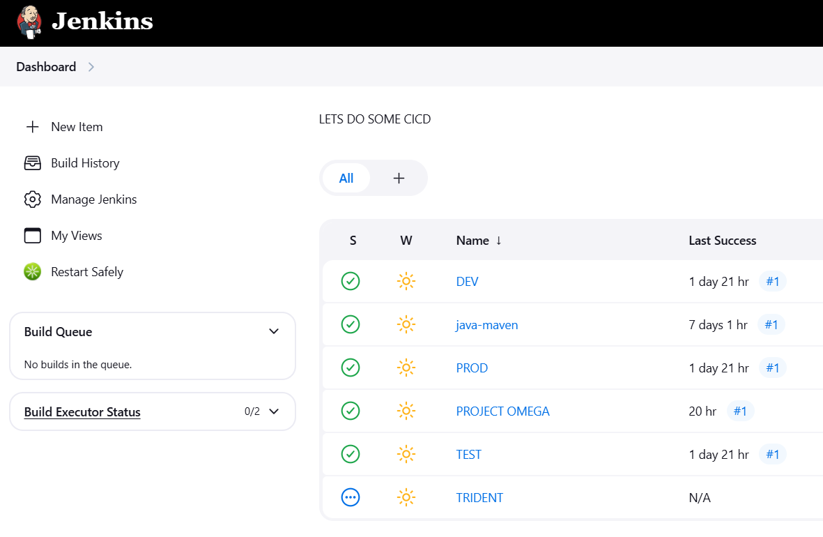

**Adding Build Parameters**

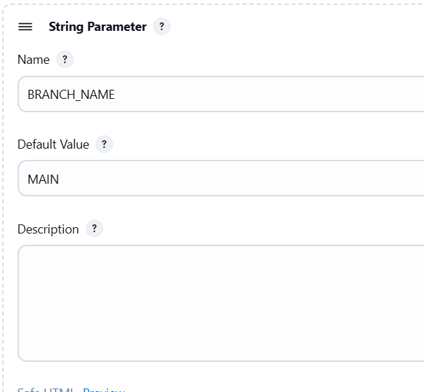

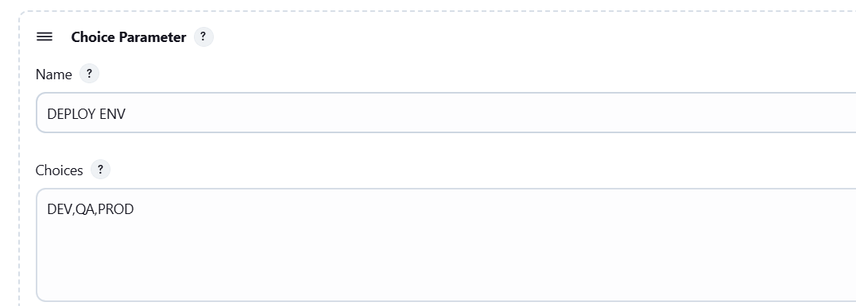

**Configuring Periodic Trigger**

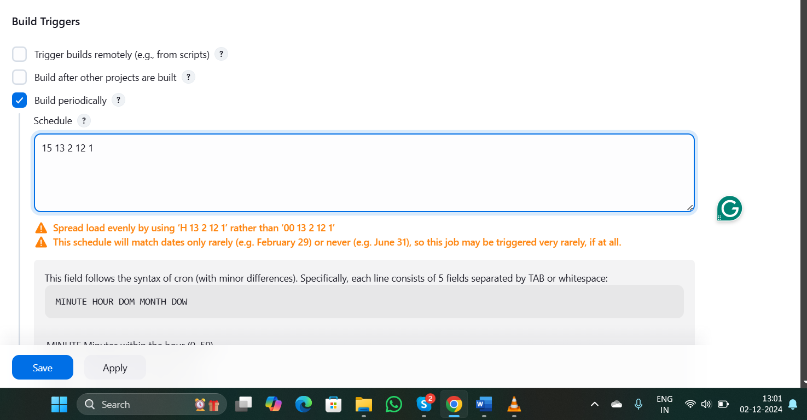

**Build Steps Configuration**

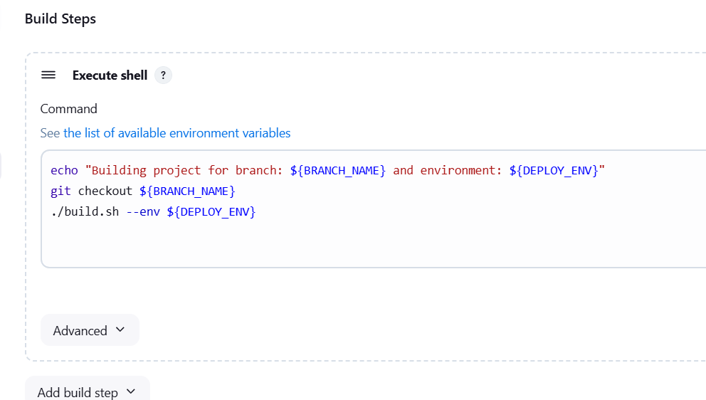

**Configuring Email Notification**

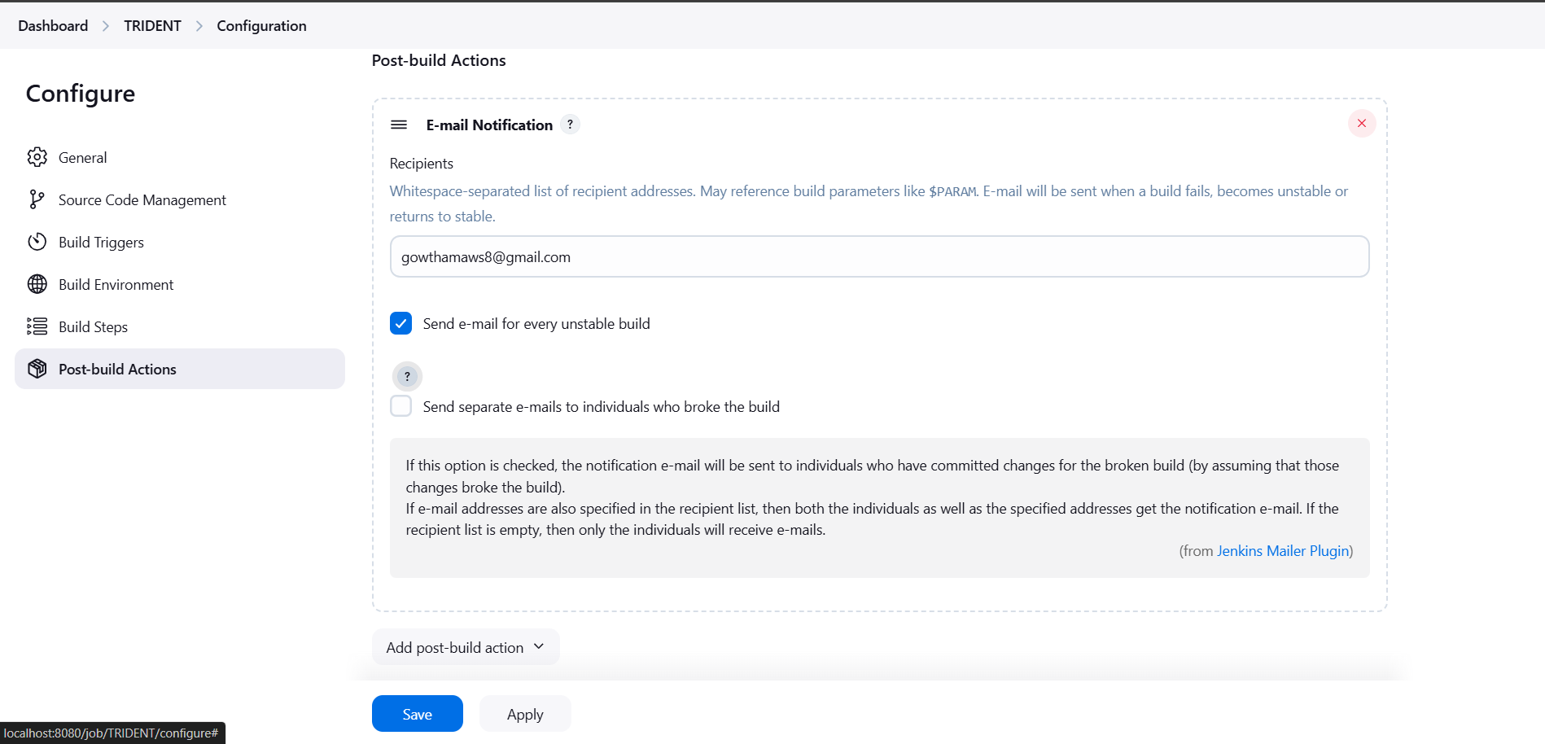

**OUTPUT**

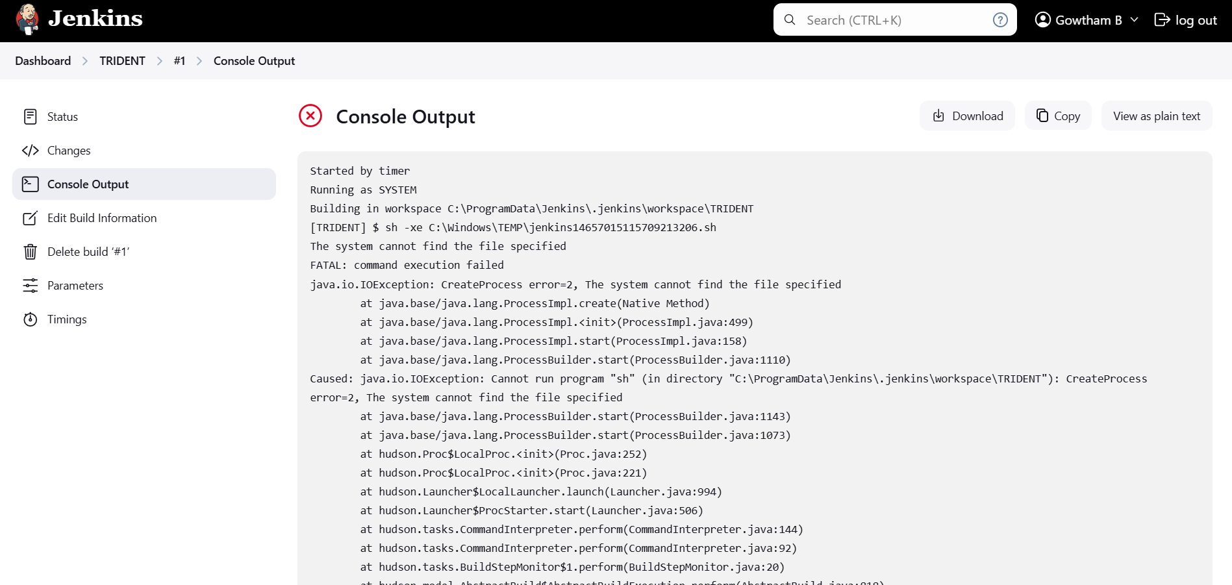

**EMAIL**

